District Rocky Mountain held our summer meeting at the Dry Dock Brewery in Aurora on August 10th. Kevin DeLange, the owner of Dry Dock Brewery, spoke to a packed house on the subject of “The Rapid Increase of Small Breweries in Colorado.”

As is traditional, the meeting started off with a social hour featuring a large selection of 14 Dry Dock beers, and those who were interested took self-guided tours of the brewing facility. A quick tour with Kevin revealed that they employ a 7bbl brewhouse from which they brew 2 brews a day, 5 days a week, making about 2500-3000bbls a year. They employ 3 full time and 3 part time brewers. They are now filling kegs from their 7 20bbl serving tanks to distribute to various on-premise accounts around the area. In January they also started packaging 22oz bottles in 4-5 different varieties. Still nonetheless, 75% of all beer they make is still poured in their tap room, of which 2/3 is drunk on premise and 1/3 goes home as growlers. The biggest sellers they have are their German styles, especially the hefeweizen.

After the social hour, attendees enjoyed a delicious catered barbecue dinner. After dinner, President Gary Dick opened up the business meeting by welcoming everyone and thanking Kevin DeLange and Dry Dock Brewery for providing their brewery as a venue and for arranging the meal. The meeting included a membership report that we currently have 207 members and are aiming for 225 by the November meeting, a treasurer’s report, a reminder of scholarship opportunities including 2 available $450 scholarships to attend the MBAA national convention, and a description of what to expect from September’s upcoming out-of-towner meeting. Additionally, Larry Leinart spoke about a very cool beer festival that he attended at Brewery Ommegang called “Belgium Comes to Cooperstown.”

Technical Chairman Finn Knudsen of Knudsen Beverage Consulting then introduced the guest speaker, Kevin DeLange. Kevin started Dry Dock Brewery in 2005, in the retail space adjacent to the home brew shop, The Brew Hut, which he has owned and run since 2002. Like most of the brewers who have opened breweries in the last few years, Kevin comes from a home brewing background himself. He learned to develop recipes (and to detect off-flavors!) as brewers would come into the shop and describe what they’d made and ask him to taste it. Additionally, he developed relationships with many local suppliers and brewers through the Brew Hut.

The driving forces for opening a brewery in that space included an enthusiastic customer base at the Brew Hut, availability of local used equipment including a brewhouse from Palisade Brewery, and the belief that there was demand for a brewery in the area marketed solely through the home brew shop and by word of mouth.

In 2006, when Dry Dock when a gold medal for their ESB, suddenly they were getting lots of press and they found they could not keep up supply to meet demand. Dry Dock expanded in both 2009 and 2011. They are interested in starting a larger barrel program. They now have the space, but are not able to keep the beer around long enough. Mirroring the popularity of Dry Dock’s beers with consumers, in 2009, Dry Dock won the Small Brewer of the Year award at the Great American Beer Festival.

Kevin’s main thesis was that the Colorado market is directly responsible for the success of the “tasting room model” of a brewery that sells beer primarily to costumers in a retail setting. The advantages in Colorado include: the ability to self-distribute, a mature home brew culture that prioritizes drinking locally, no chain store sales so the smaller business models can compete, and no laws mandating that this model sell food.

Dry Dock is certainly not the only brewery to have figured out that this can be a successful business. There are ~ 25 breweries scheduled to open within the next 12 months. And many larger breweries such as Odell and Avery have recently expanded their tasting rooms because they are such a huge revenue source.

Kevin concluded by questioning whether this model is sustainable with so many new players entering the market. In his particular case, because Aurora has such a large population but only 1 brewery currently, he argued that there is definitely room for more competition. And as more breweries come to town, the key to success will not just be to make beer but to make good beer. Dry Dock has been able to grow because they were able to reinvest in expansion, and were he to be ready to expand further, he’d likely open a 2nd tasting room rather than keep expanding in the current location. And while legislatively Colorado is very friendly to this business model currently, there’s no guarantee that this will not change over time.

As is customary, the evening concluded with a very lively raffle of prizes supplied by many of the members, including a large selection of shirts and glassware. The next meeting of District Rocky Mountain will be held in Glenwood Springs, CO on September 16-18th, hosted by the Glenwood Canyon Brewing Company.

Tamar Banner
Publicity Chair
Master Brewers Association of the Americas - District Rocky Mountain
August 31, 2011
Attached photos:

Photo 1: Steve Woodward and Dave Kleen, goofing around during dinner.
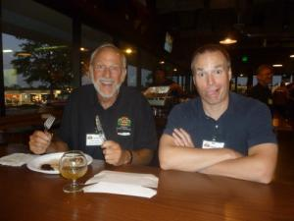
Photo 2: Matt Smith, Patty Robinson, and Shannon Madruga, pouring Dry Dock beers for thirsty brewers.
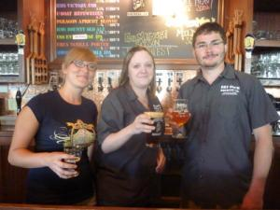
Photo 3: Seen hanging in the brewhouse…
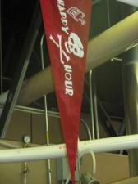
Photo 4: Tech. Chair Finn Knudsen presenting Kevin DeLange with a thank you gift for his presentation.
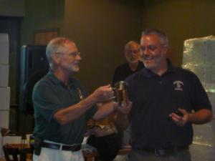
Photo 5: Gary Dick and Steve Presley, running the raffle.
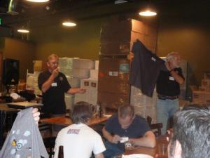
Photo 6: Steve, John, and Ryan of Gravity Brewing with Jason Stengl.
